**GROCERY CA**RT

***Under***

**Google Virtual Internship**

***by***

**Smart Internz**

**Done by**

Gajavalli.Manikanta sairam

Email:maniprince0908@gmail.com

**Grocery shopping App- ANDROID MOBILE APPLICATION**

A Project Presented to the faculty of Smartinternz, by **Gajavalli.Manikanta Sairam**

**Abstract**

Shopping is an intrinsic part of everyday life. The purpose of creating shopping lists is to efficiently manage time and resources while shopping and not forget something important to buy. These shopping lists could range from grocery shopping to shopping clothes, accessories, jewelry, gifts for special occasions, etc. The paper-pen based approach is no longer the only or effective means of creating shopping lists.

With the advent of the mobile phone era and the frequent use of mobile apps to perform everyday tasks, the trend to use apps for creating and managing shopping lists is becoming more popular by the day. There are hundreds of “Shopping List” apps for both Android phones and iPhone. Also, the design of the mobile app interface contributes a significant share in human computer interaction (HCI) research. The goal of this paper is to study the transformation from paper-pen based approach to the mobile app approach, analyze user experience with the most popular shopping list apps for both Android and iPhone; and suggest new ways to improve this experience both in terms of usability of app and user interface improvements.

Before going to the grocery, it is very important to list the things you need to buy. You don't want to end up purchasing goods in the grocery and later realize that you forgot an item or two. Making a list can also help you sort out and prioritize the items you need to buy.

**Hardware Interfaces**

Grocerycart operates similarly on various mobile devices with different physical characteristics that run on Android operating system. Since the Android client will be implemented as a thin client, meaning the most of the computing and data storing will be done on the server side, the mobile application will not consume a lot of CPU or phone memory. The GPS will be needed for the purpose of locating the user and getting the nearest store or stores around him in a radius specified by use. It provides the exact location all the time and will be integrated with Google Maps, so the users can see their location and the location of the stores on the map. The phone camera functionality will be used for barcode recognition and scanning.

Mobile application graphic user interface

The main graphic content will be implemented using embedded basic layouts and widgets which ADT provides. One of the design decisions is that the user‟s screen orientation will be locked in a portrait mode view. The user will start the application by selecting the Grocerycart icon in the application menu. Error and help messages pop up when they have initially occurred.

A good GUI has to be:

• Intuitive

• User-friendly

• Fast

The following figures illustrate just an example for a possible GUI for the application.

The application GUI is made to be simple which is shown in Figure 2.1. On the main screen there are just 3 essential buttons which lead on other views: Products, Shopping list and Stores.

We can see that there are three building blocks of our software.

**1. Android Client**

The client application exposes the system functionalities to the users. The client communicates with the server and consumes the web services offered by the server. The android application will be implemented as a thin client, which means that most of the computing and the data will be stored on the server side of the system. In the future that will enable faster, easier and consistent development of the Grocerycart mobile application for other mobile platforms such as Windows Phone 7.

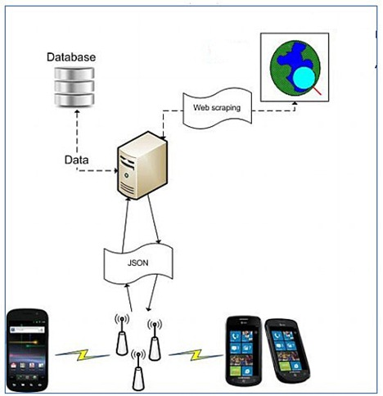

**2. Grocerycart Server**

The server application encapsulates the major functionalities of the system. These functionalities include web services management, storage management, and user authentication.

**3. Web Services**

The web services function as a middleware of our system. The client requests are sent to the server through the Internet and handled by the server. Grocerycart will be using JSON based web services because of the reduced overhead related to parsing responses/requests as compared to the SOAP/XML.

**IMPLEMENTATION**

Implementation is the stage of the project when the theoretical design is turned out into a working system. Thus it can be considered to be the most critical stage in achieving a successful new system and in giving the user, confidence that the new system will work and be effective. The implementation stage involves careful planning, investigation of the existing system and it’s constraints on implementation, designing of methods to achieve changeover and evaluation of changeover methods.

**MODULES:**

**1. Contacts:**

Add new contact (First name, Last name, Number)

**2. Email contacts:**

Add new email contacts (Mailer name, Email address

**3. Word Activation:**

Enter the word you want to use activate the alert

➢ Word activation off

➢ Decibel system off

**4. Personal Information**

➢ Change Password (Enter old pin, Enter new pin, Re-enter new pin)

➢ Change Details (First name, Last name, Address)

**5. Information Help**

➢ When you want to activate the attack application , press the panic button.

➢ When it is in active state , you can deactivate the application by pressing the deactivate button. You then enter your 4 pin code and press ok to deactivate it. You only have 10 seconds to do.

➢ Click setting to change application operation. Click on contacts and add new contact. This will be the person you send the information to.

➢ You can add as many contacts as you want. You can delete a contact by holding the button of their name.

➢ When you first click email contacts button, you will be asked to enter in your Gmail address and password to access that Gmail account emergency. When you fill in the form you can then add email contacts like you did with phone contacts.

➢ When you click word activation, you can set the word you want to activate the app. Press save when you typed it in. if you want to turn the word activation on, click it on at the bottom. You can also activate a decibel system where it will go off when it reaches a certain noise level

➢ Click change password to change your old password to a new one. click change details if you want to change personal information

**SYSTEM REQUIREMENTS:**

**HARDWARE REQUIREMENTS:**

System : Pentium IV 2.4 GHz.

Hard Disk : 40 GB.

Floppy Drive : 1.44 Mb.

Monitor : 15 VGA Colour.

Mouse : Logitech.

Ram : 512 Mb.

MOBILE : ANDROID

**SOFTWARE REQUIREMENTS:**

➢ Operating system : Windows XP.

➢ Coding Language : Java 1.6

➢ Tool Kit : Android 2.2

➢ IDE : Eclipse

**Design Approach**

This project is based on the functional design approach, which helps in understanding the design of the project in a simpler way by explaining its flow, use cases, and implementation more like a modular approach. For example, there are different modules in this project which have separate functionality and, other sub functionalities/modules. All the modules are designed, implemented and integrated together to make a flawless working application.

**Detailed Design**

The detailed design including modules and sub modules of the application is as follows:

**1. User Registration:**

If the user wants to use the Grocerycart, they must download the application from the play store, install and register it by providing login information. Once, they registers the registered information is stored on the server and can be validated, checking the valid credentials for the next time he logins with the application.

**2. Instant Search:**

The instant search helps in finding whether the item is available in the store or not. This could help the users save time by searching for the item which is out of stock

**3. Scan the Item:**

This feature helps people by allowing them to scan the barcode that is available on the item. Once the user scans the item, they can see all the information about the item like barcode number, name, quantity, price, net price, and serial number. Users can scan any number of items they wish and keep adding to their physical shopping cart. Later, they can purchase any item they want by checking the items in the cart. Suppose if the stock is not available for any items, “stock not available” message is also shown.

**4. Checkout and Payment:**

Checkout is made in an easy step to avoid hassle in this application. The user can just check in with the checkbox from the cart. Depending upon the quantity of the items, the payment is calculated along with the tax rate (Ex: 8%). If the user wishes to purchase, they can proceed by clicking the “PayNow” button or they can cancel the purchase at this stage and proceed and with shopping for other items or they can exit the application.

**5. Invoice Generation and Uploading:**Once, the user confirms the purchase and pays the amount, the invoice is generated at the same time and we can share it instantly to cloud (share to drive, send email)

**6. Tracking Purchase:**

The application allows us to track purchases by adding the various expenses we spent and view them in the form of charts (pie chart) as for other charts like line graphs, bar graphs we need a large dataset. Viewing expenses is interactive with different options like view by category, by and between dates, or view all.

**IDE’s, Tools and Technologies:**

**Android Studio Android Studio**

Android Studio is exclusively designed for developing Android applications. It consists of all Android SDK tools to design, develop, maintain, test, debug and publish our app. The IDE is designed very efficiently which makes the developer’s job easy. It also supports the IntelliJ IDE, the main idea behind this IDE is that it automatically senses the variables, methods, classes, built-in functions or it could be anything else when we press the first letter of it. Say, suppose we declared few variables or methods that starts with an ‘S’, it automatically senses everything that starts with an ‘S’ and makes suggestions. It also supports Git as a version control system to maintain the app changes and push them into github. All java files, layout files (for design) are integrated into a single project easily. After the completion of project, the whole application could be put as an .APK (Android Package) file, in which we can run that APK file in any device and use the application. Other main tools include Android SDK, ADB, and Gradle Build.

**Android Software Development Kit (SDK):**

One of the main tools used in developing android applications, as it packages many core features into one SDK and it can be used in the application easily. This helps us to avoid writing lot of code, and building applications faster.

**Interface**

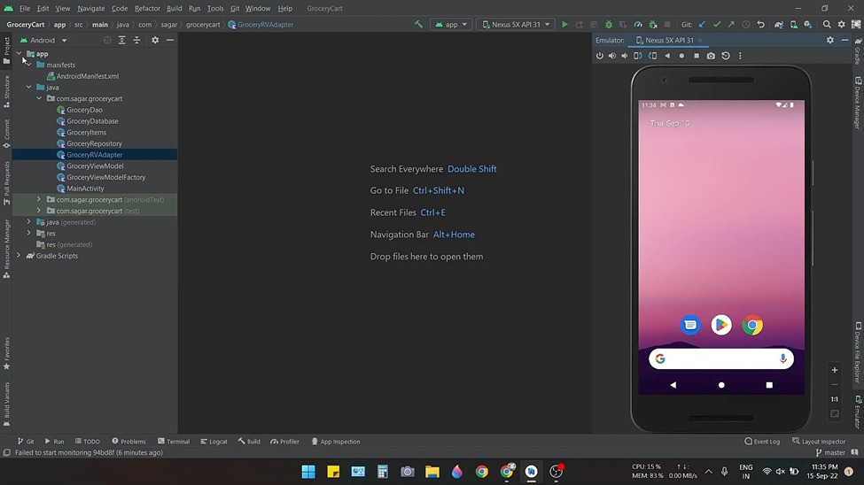

This is the opening interface of the mobile.

The images are mentioned sequentially according the UI of the application:

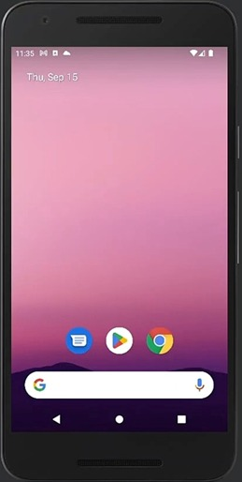

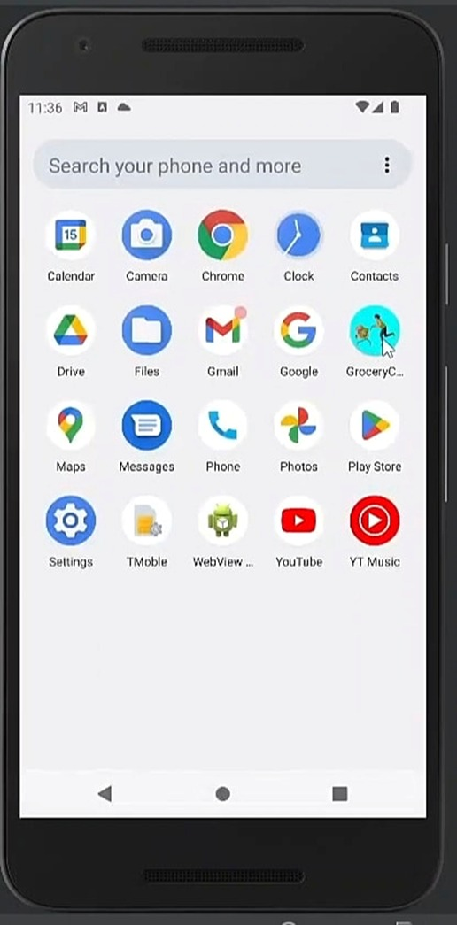

This is the LOGO of the GroceryCart Application

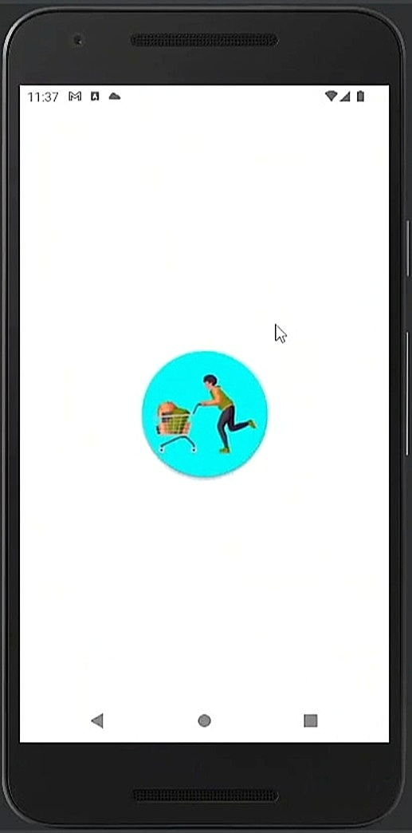

This is the User Interface when we click on Application.

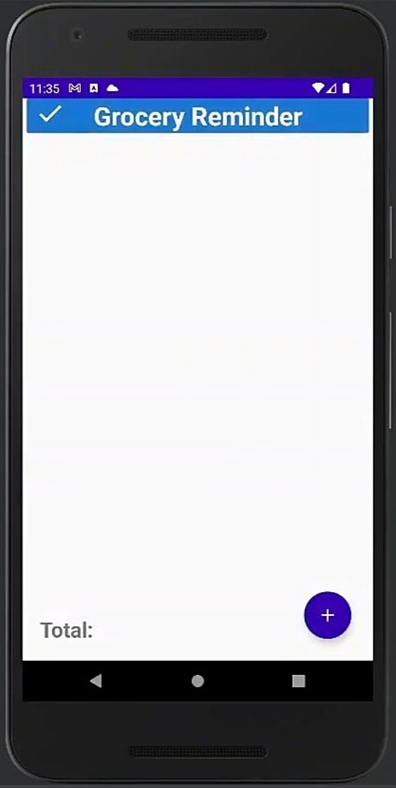

When we open the app the interface looks like this.

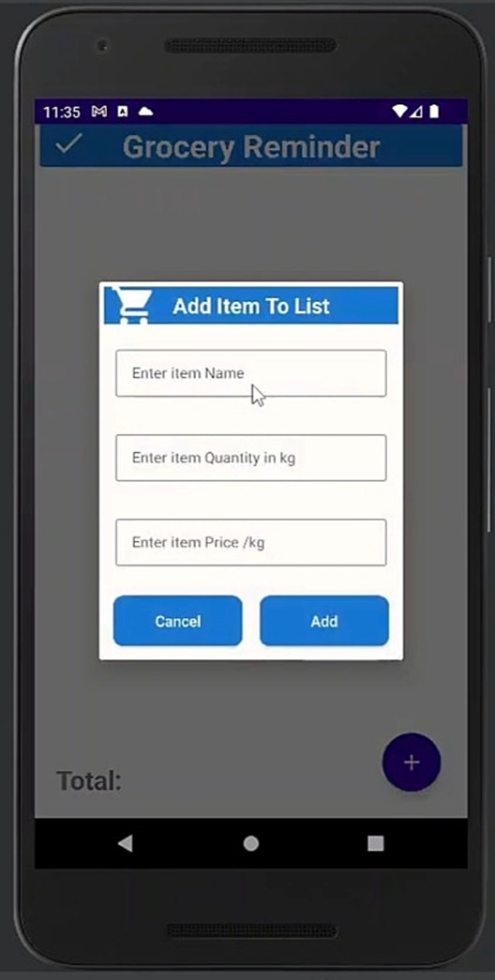 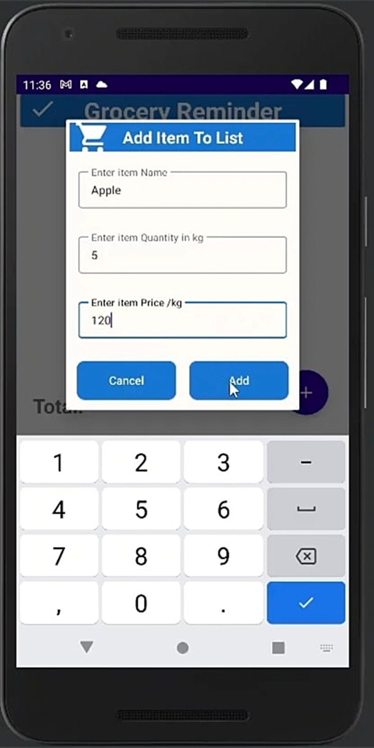

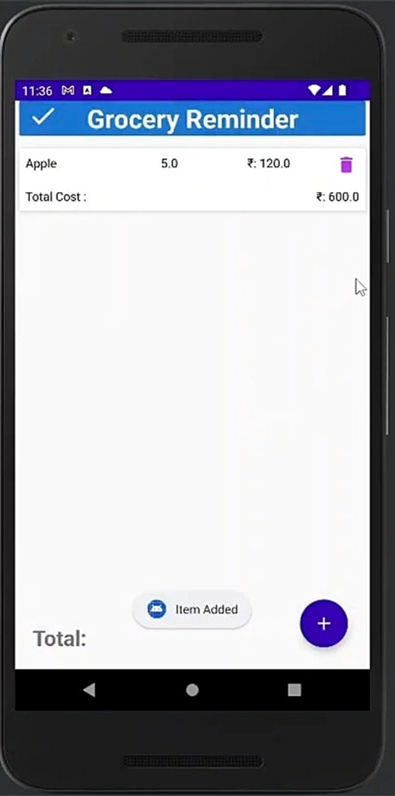 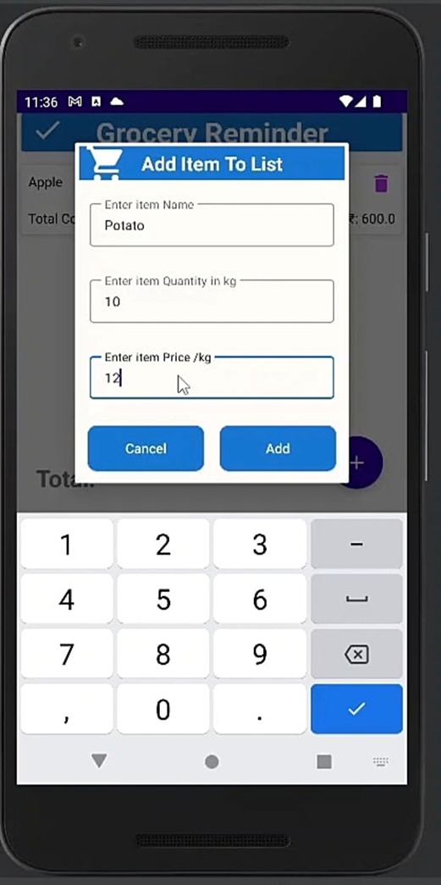

**Web References**

1.[Build a Grocery Store Web App using PHP with MySQL - GeeksforGeeks](https://www.geeksforgeeks.org/build-a-grocery-store-web-app-using-php-with-mysql/)